1.1 HUB

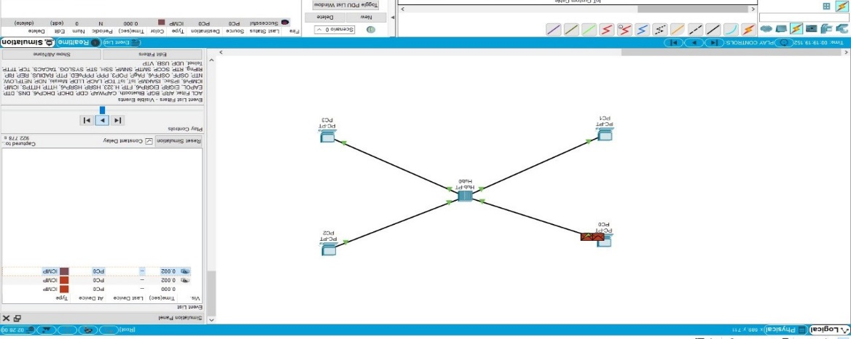

1.2 SWITCH

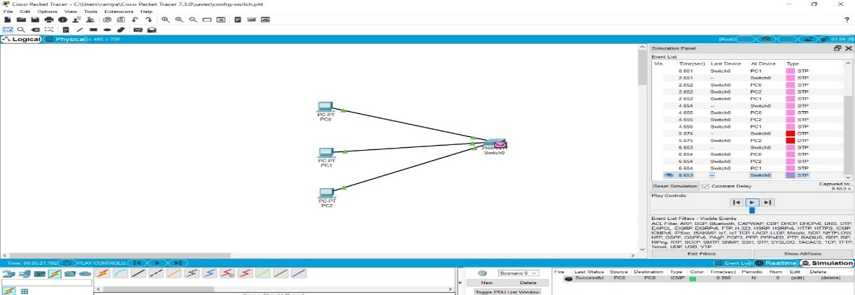

1.3 ETHERNET 1.4 BROADCAST

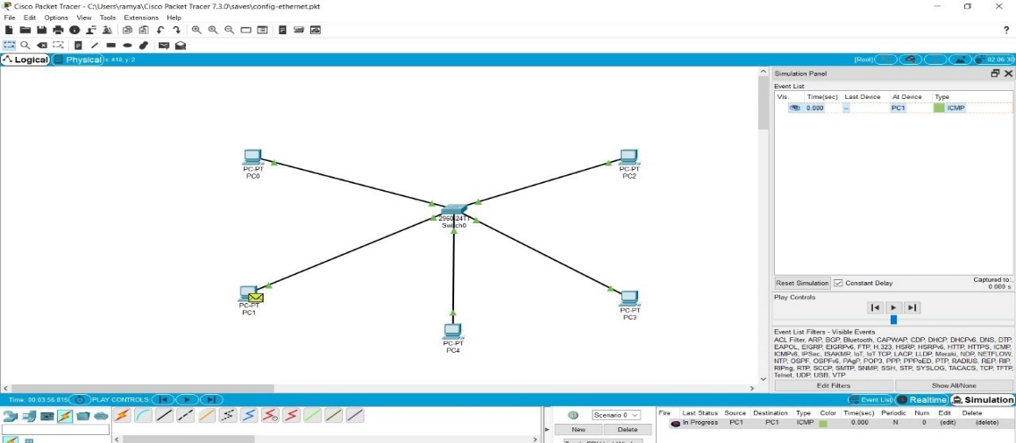

2.1 STAR TOPOLOGY

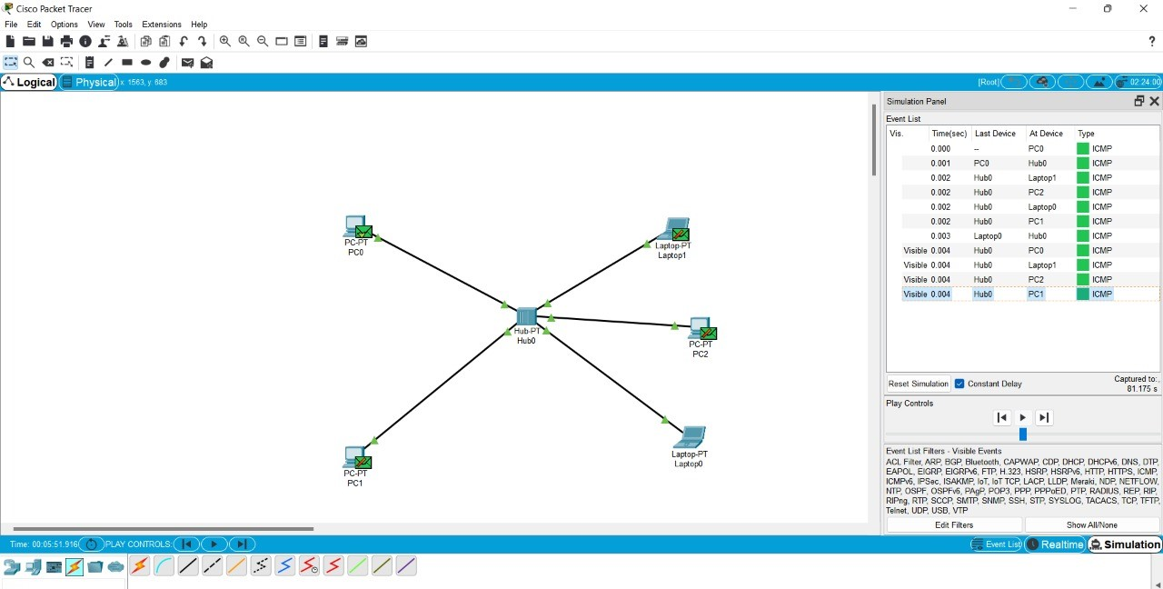

2.2 BUS TOPOLOGY

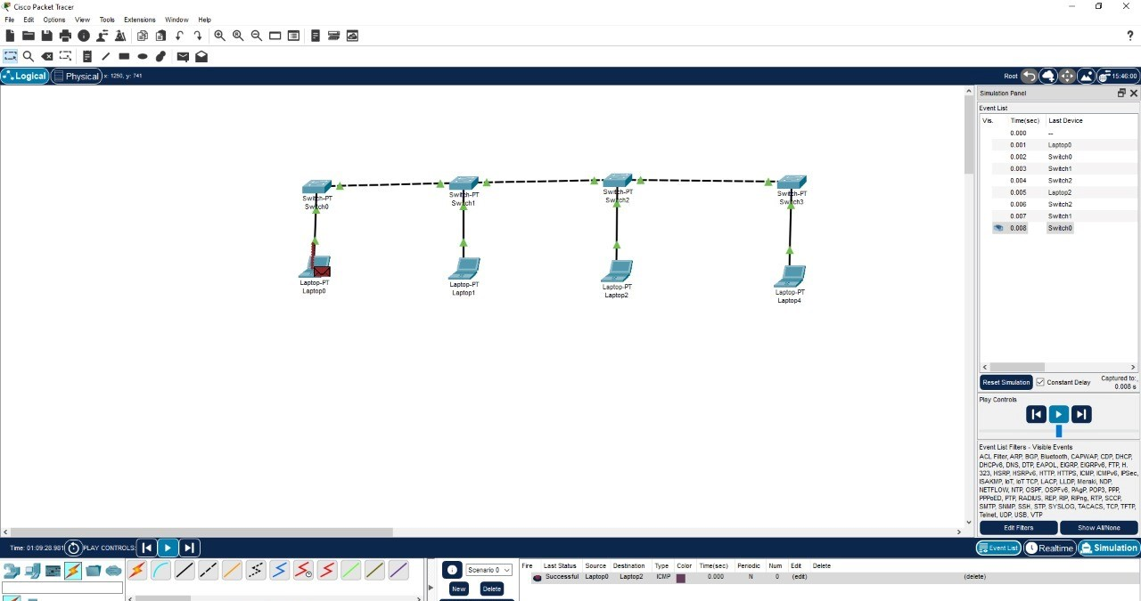

2.1 RING TOPOLOGY

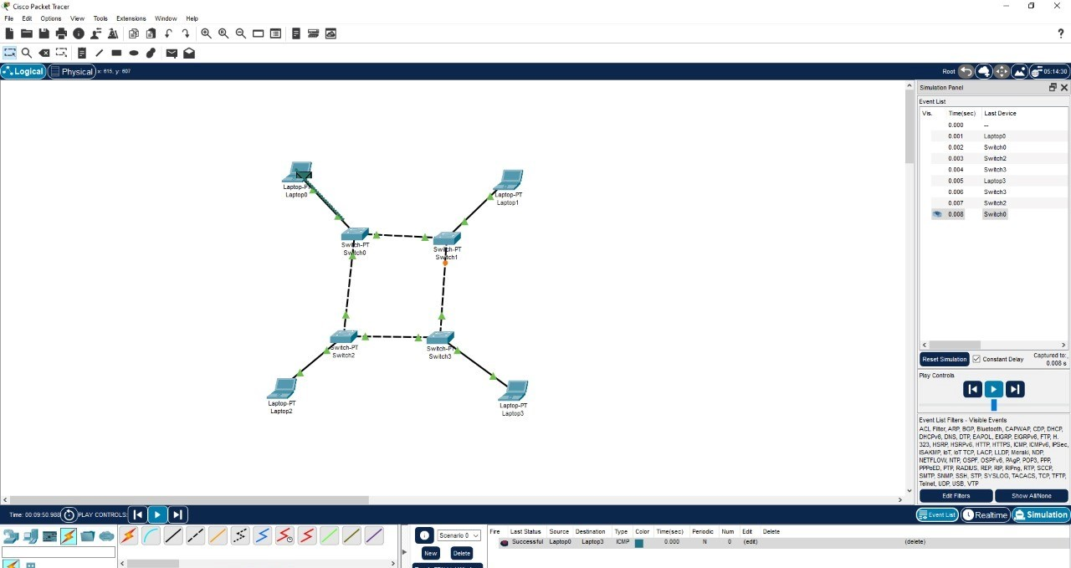

3.2 MESH TOPOLOGY

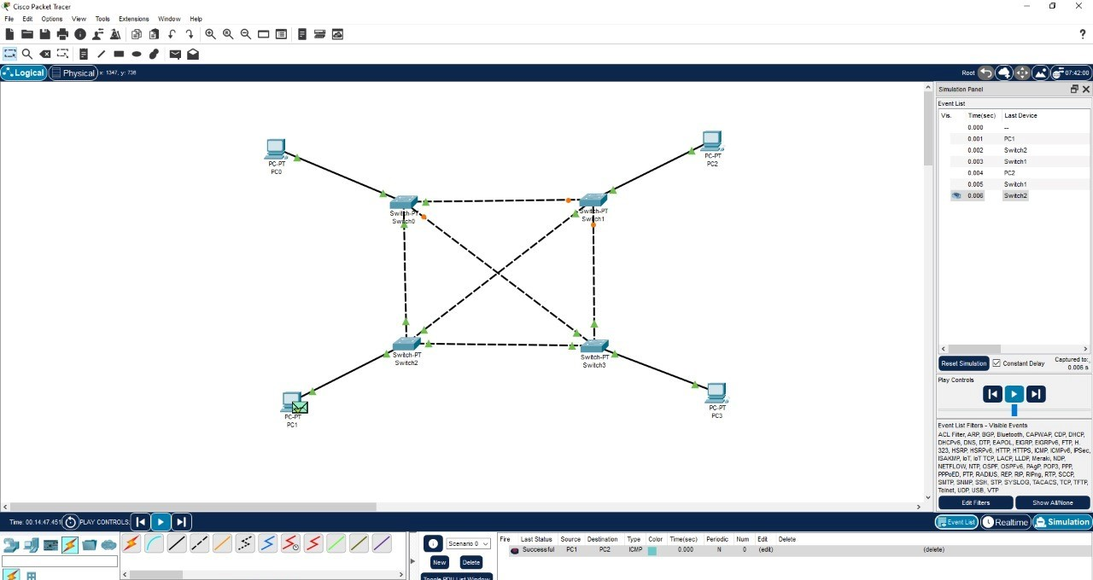

4.1 HYBRID TOPOLOGY

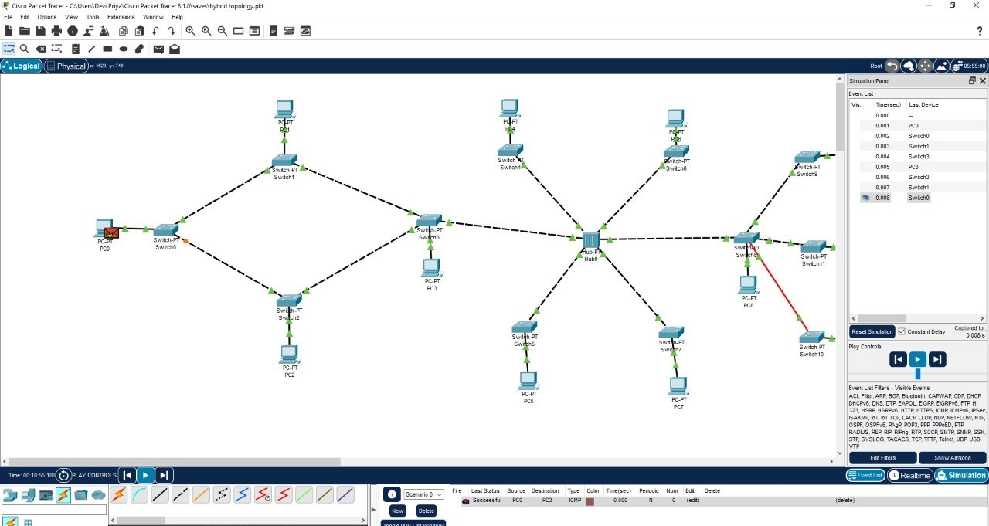

4.2 TREE TOPOLOGY

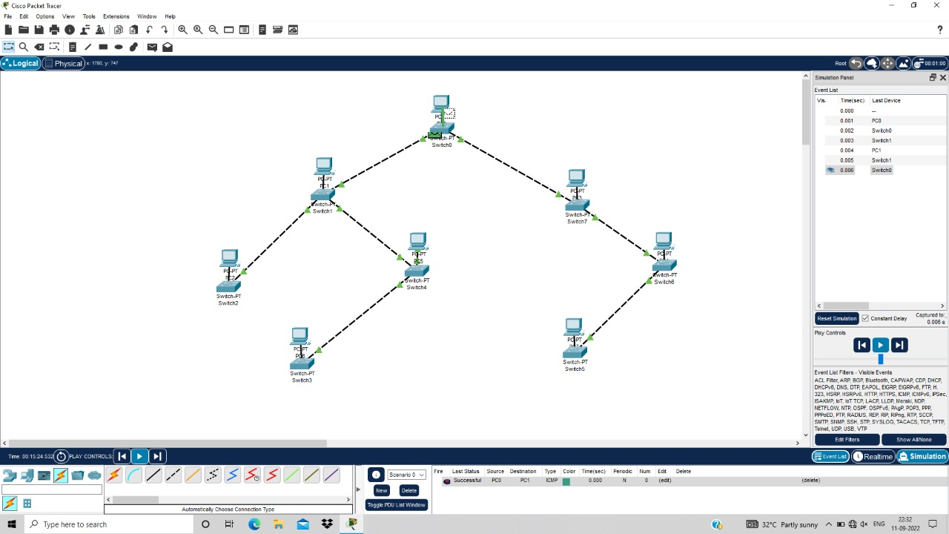

4.CSMA/CD CSMA/CA

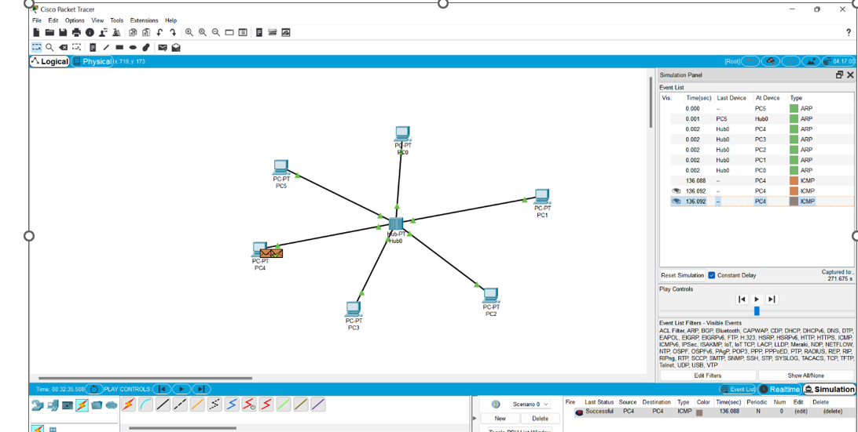

[h](https://www.google.co.in/intl/en/about/products?tab=wh)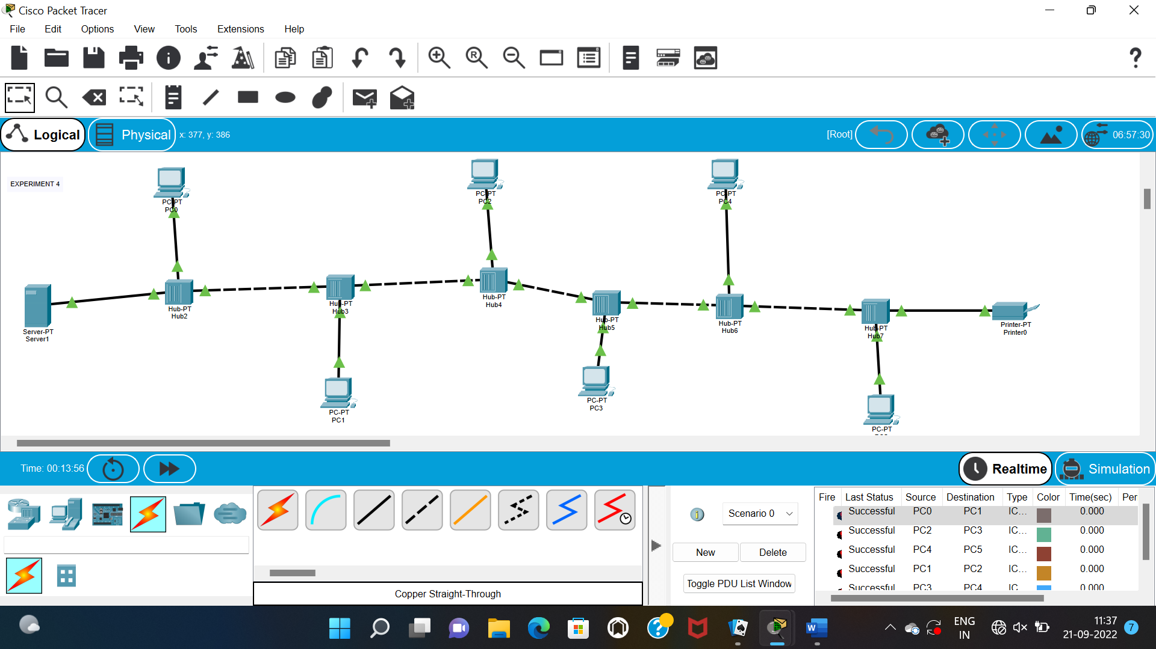

5.ARP

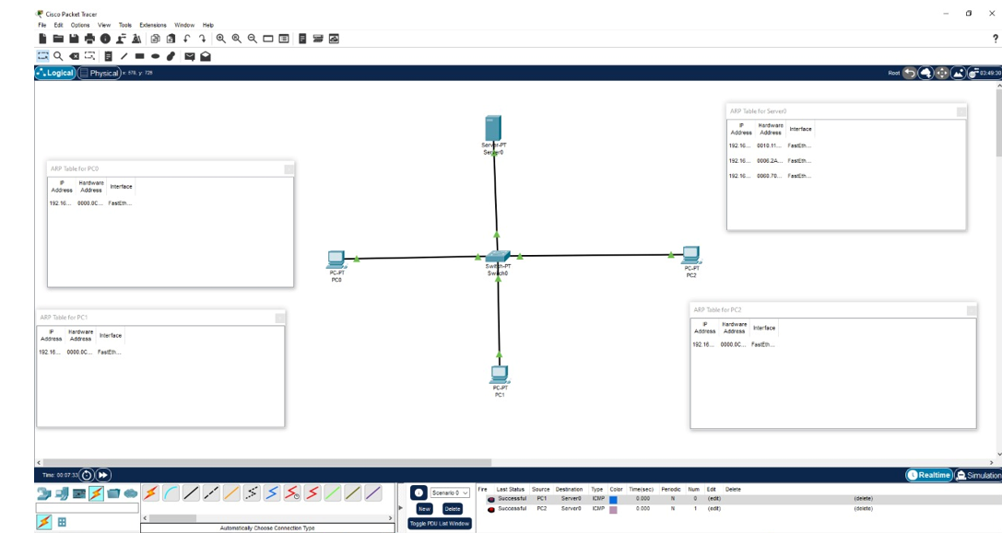

6.LLDP

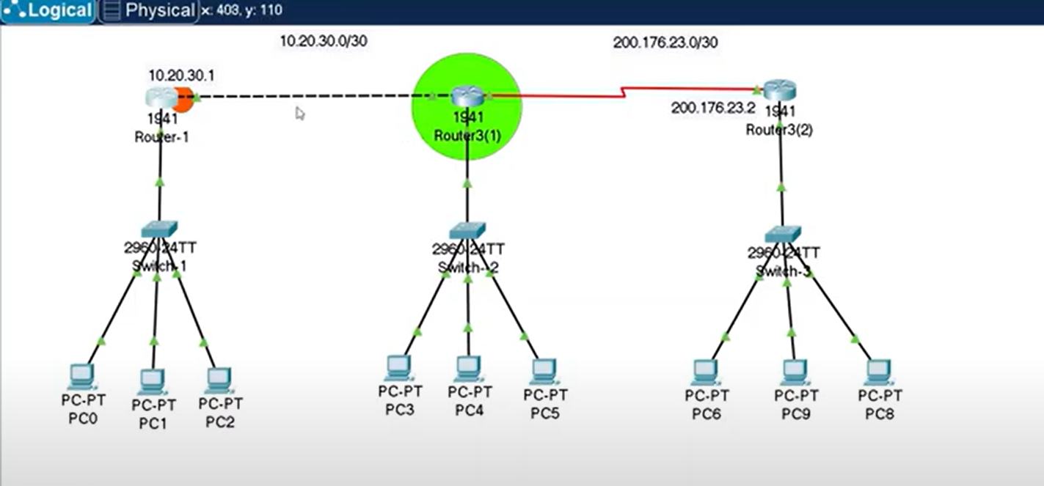

7.STATIC ROUTING

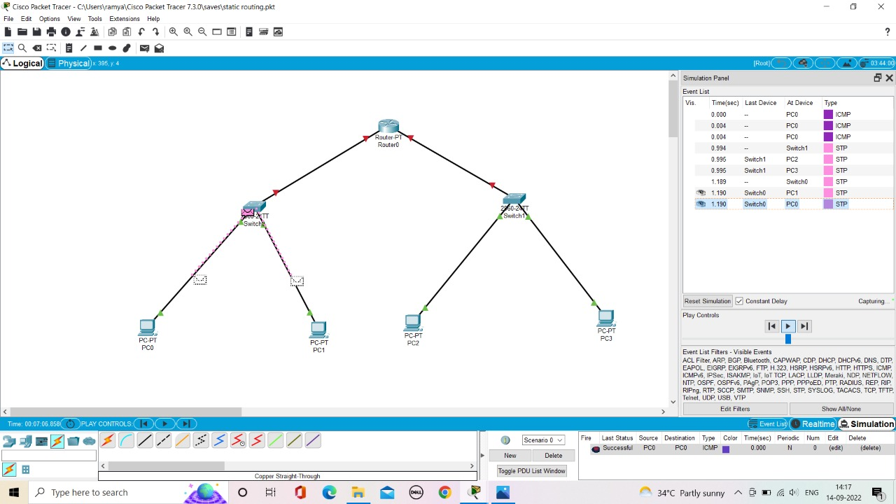

8.DYNAMIC ROUTING

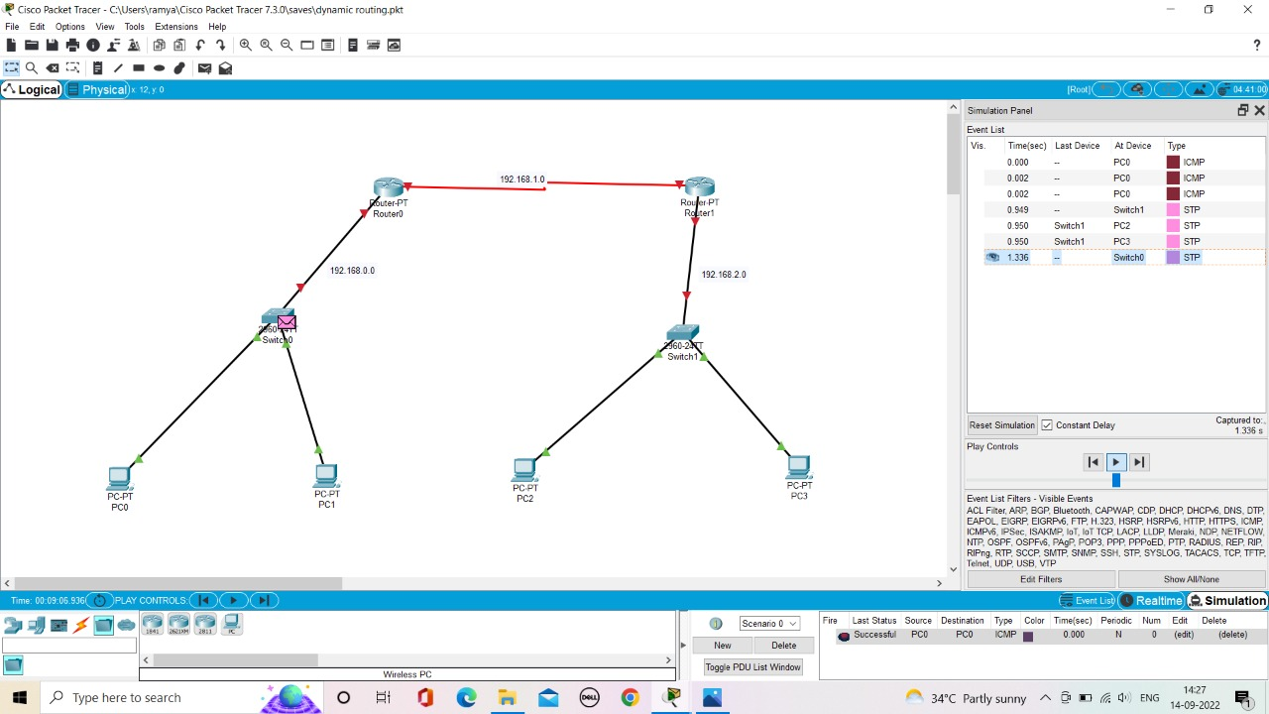

10.1 TCP EXPLORATION SOLUTION

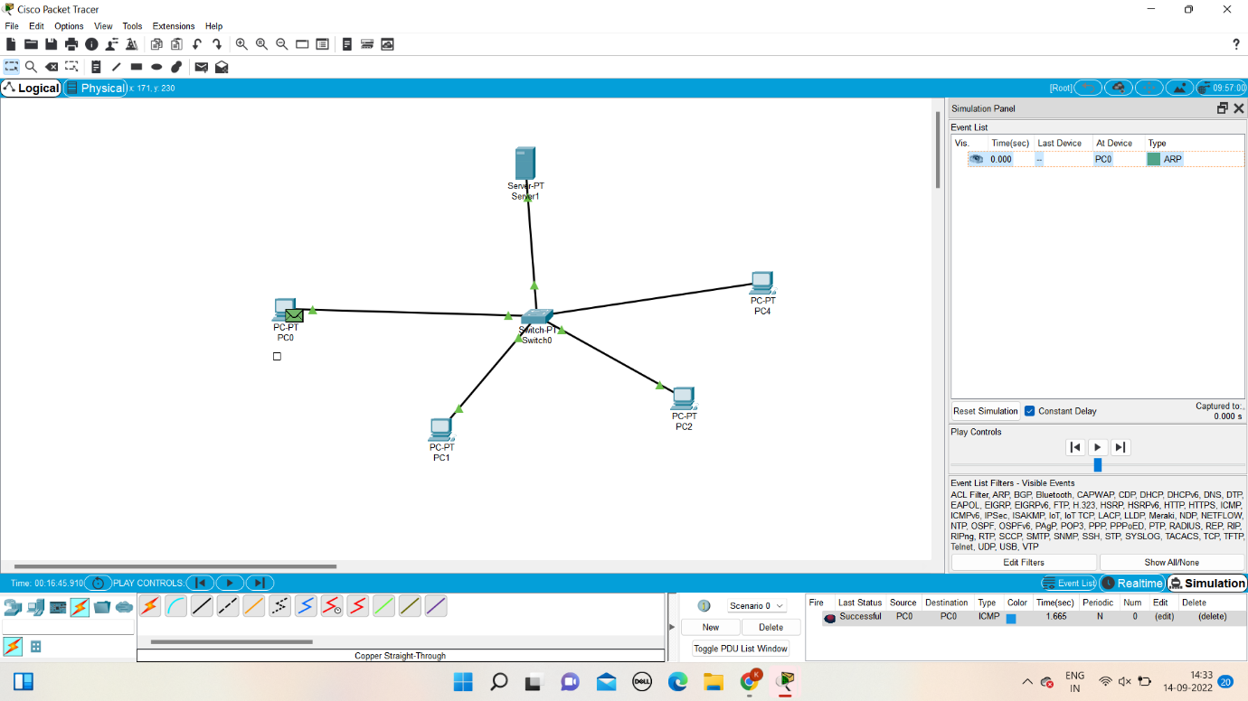

10.2 UDP EXPLORATION SOLUTION



11.SUBNETTING

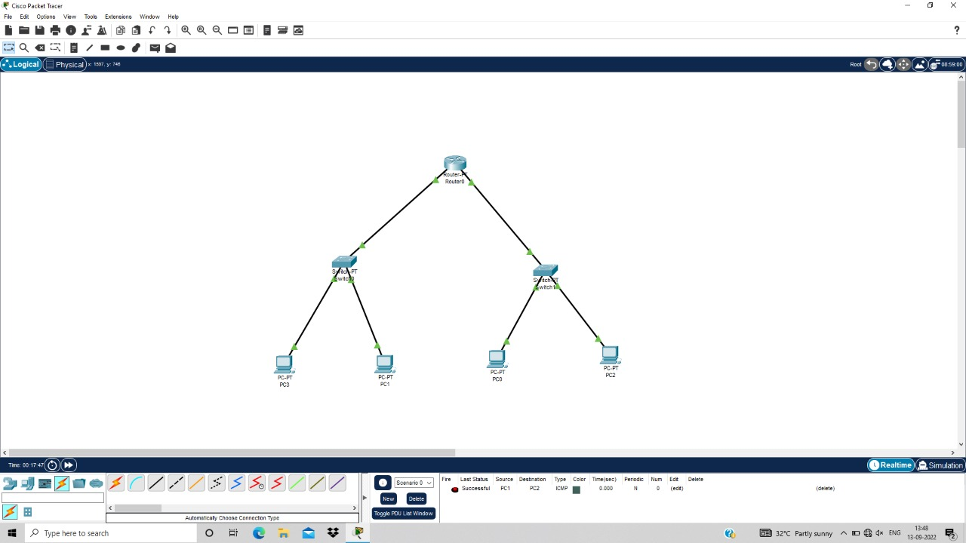

12.XYZ COMPANY

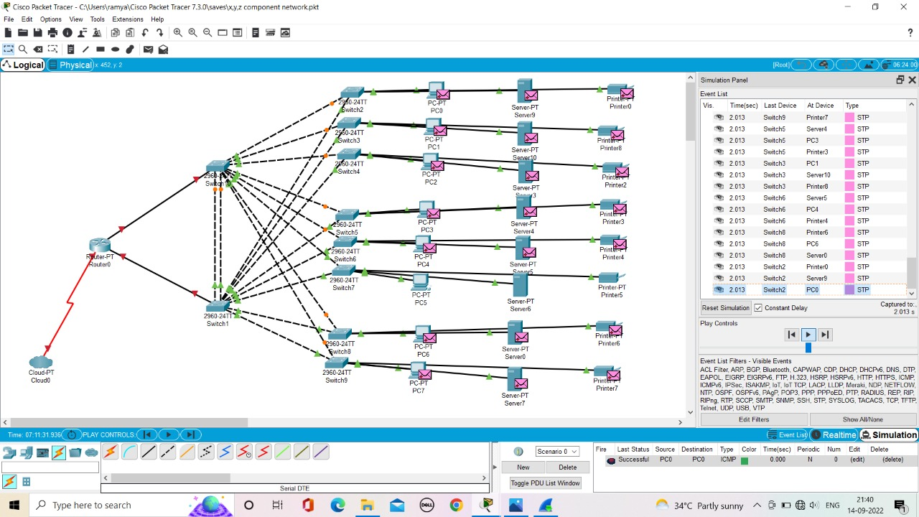

9.1 FUNCTIONALITIES OF TCP



9.2 FUNCTIONALITIES OF UDP



13.COMPUTER LAB

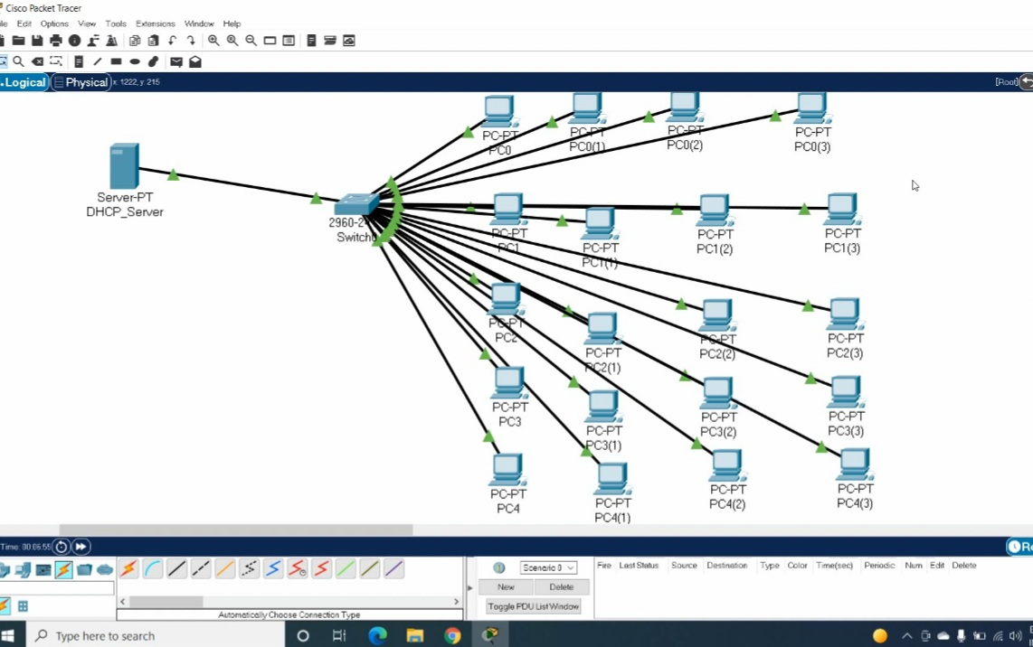

15.IOT SMART HOME

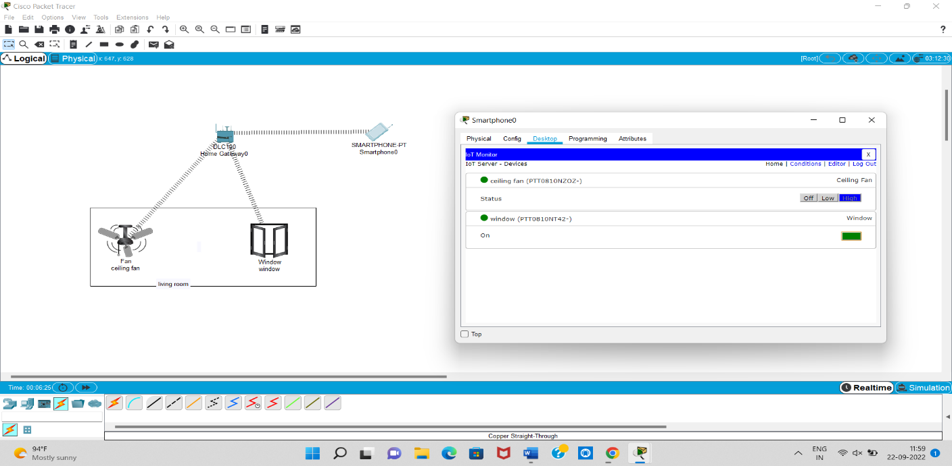

18.IOT BASED WPA AND RADIUS SERVER

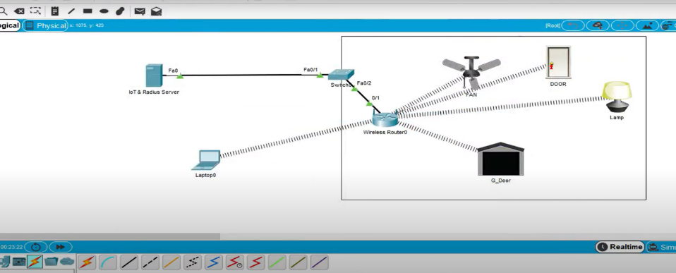

19.WI-FI NETWORKS

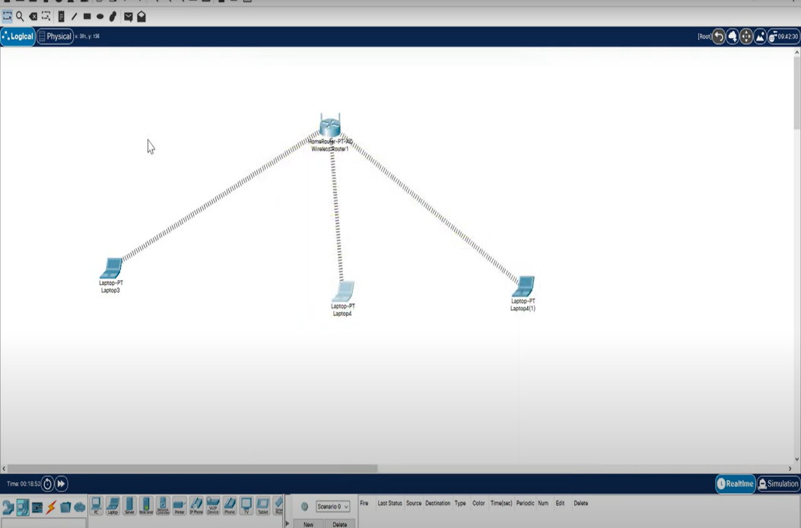

20.DVR

